Hillary Billy Ray Inigo Montoya
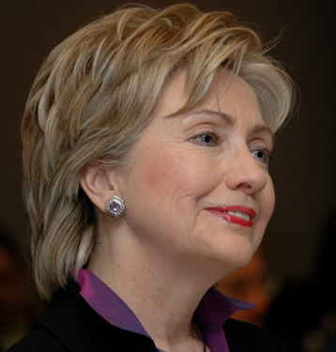 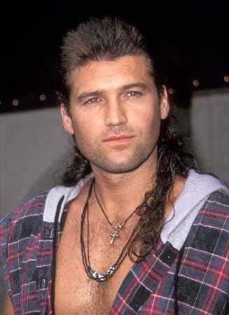 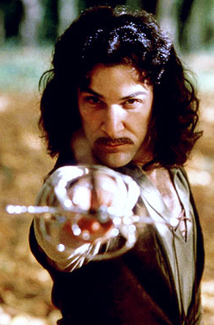
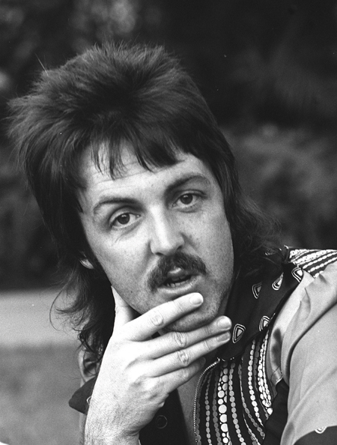
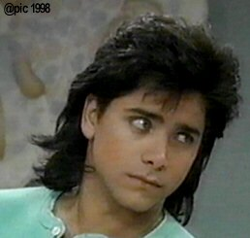
Uncle Jesse Paul Ke$ha
Mullet Ratio Worksheet
Name _____________________ Date ____________ Period_____
Calculate the Mullet Ratio for each Mullet.
Once you finish, rank the Mulletude of each one.
Top Mullets
Name | Mullet Ratio
Patrick Jean-Claude
