Shaun Bart Jeanine
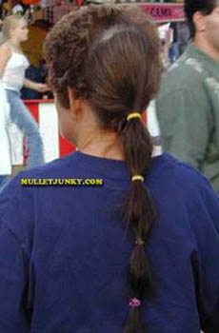
Rita Shannon Barry
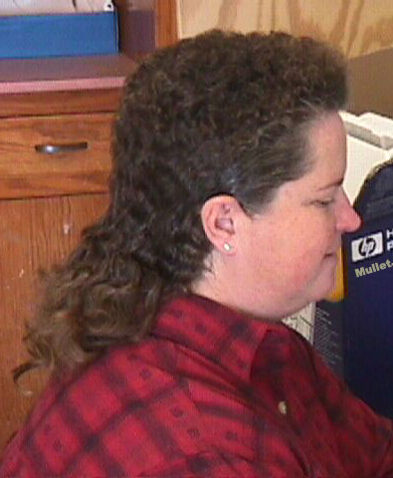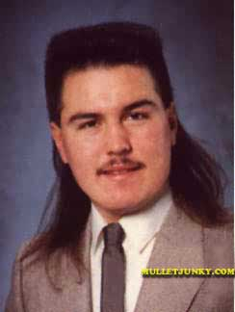
Mullet Ratio Worksheet
Name _____________________ Date ____________ Per_____
Calculate the Mullet Ratio for each Mullet.
Once you finish, rank the Mulletude of each one.
Top Mullets
Name | Mullet Ratio
Miguel Big Daddy
